Study Support in Morgan Academy Session 25/26

All departments in Morgan Academy run Study Support sessions for the courses that they deliver. Please see the detail below for each subject area. Your child’s teachers will continue to promote these sessions as part of their learning conversations with them. Please encourage your child to engage in these sessions, particularly if they require further support, explanations or clarification with classwork and homework and particularly in preparation for prelims and assessments.

Department | Course | When? | Year Group
Art and Design | All levels Art and Design | 3 to 4pm Wednesday 6th November  3 to 4pm Wednesday 4th December  3 to 4pm Wednesday 15th January  3 to 4pm Wednesday 5th February  3 to 4pm Wednesday 12th March  Department open every lunchtime. | S4/5/6
English | N5/H English | Thursday Lunchtime in E2 | S4/5/6
English | N5/H English | Thursday afterschool in E6 | S4/5/6
English | N5/H English | Tuesday and Thursday lunch and after school in E5 | Higher Dream Team
English | N5/H English | Other – upon request with teacher | S4/5/6
Geography | ALL Classes | Wed lunchtimes | S4-6
History | N5 History | Tuesday Lunchtime & Thursdays after school (Alternate) | S4/5/6
History | H History | Wednesday after school | S4/5/6
History | N5 Ancient History | Wednesday after school | S4/5/6
IT Faculty | All Levels Computing Science | At a time scheduled with class teacher – ad hoc | S4/5/6
IT Faculty | Games Development | At a time scheduled with class teacher – ad hoc | S5/6
IT Faculty | N4/5 Business Management | Tuesday lunchtime | S4/5/6
IT Faculty | H Business Management | At a time scheduled with class teacher – ad hoc  Thursday lunchtime | S5/6
IT Faculty | N4/5 Administration and IT | At a time scheduled with class teacher – ad hoc | S4/5/6
IT Faculty | N5 Accounting | At a time scheduled with class teacher – ad hoc | S4/5/6
IT Faculty | H Accounting | At a time scheduled with class teacher – ad hoc | S5/6
Maths | All levels  N5 Applications | Tuesday Lunchtime  Wednesday after school  Thursday after school  Friday Lunchtime | S4/5/6
Modern Languages | All Levels Spanish | Individually by arrangement with Miss Dailly | S4/5/6
Modern Studies | ALL Classes | After School Wednesday | S4/5/6
Music and Drama  Physical Education | All levels Music and Drama  PE | Music practise space available at lunchtimes.  Thursday Lunchtimes | S4/5/6  S4/5/6
RMPS | All levels RMPS and Philosophy | By request Monday to Thursday lunchtime and end of school day | S4/5/6
Science Faculty | All Levels Biology, Applied Science | Tuesday and Wednesday Lunchtimes | S4/5/6
Science Faculty | All levels Chemistry  Crash Higher Chemistry  National 5 Targeted Group | At a time scheduled with class teacher  Tuesday After school  Wednesday lunchtime or afterschool | S4/5/6  S4/5/6  S4/5/6
Science Faculty | All Levels Physics | Wednesday and Thursday after school (lunchtimes on request with teacher) | S4/5/6
Technologies Faculty | N4/5 Practical Woodwork | Tuesday lunchtime | S4/5/6
Technologies Faculty | N4/5 Engineering Science | Tuesday & Wednesday after school | S4/5/6
Technologies Faculty | H Engineering Science | Tuesdays after school | S5/6
Technologies Faculty | N4/5 Graphic Communication | Tuesday & Wednesday after school | S4/5/6
Technologies Faculty | H Graphic Communication | Any lunch except Friday | S5/6
Technologies Faculty | N5 Practical Cookery | Monday & Tuesday lunchtime | S4/5/6
Technologies Faculty | N5 Practical Cake Craft | Wednesday lunchtime | S4/5/6
Technologies Faculty | N4/5 Early Learning and Childcare | Wednesday lunchtime | S4/5/6
Technologies Faculty | L6 Social Services / H Childcare | Any lunchtime or study period | S5/6
Technologies Faculty | N4/N5/H Fashion & Textile Technology | Tuesday lunchtime or after school | S4/5/6

Revision guides, past papers and marking instructions


Click on the images below to find further support.
- SQA study tips and past papers

- Past question papers:
- BBC Bitesize: Resources and information to support revision.


- Visit Revision in a Nutshell National 5 and Higher subject guides National Parent Forum of Scotland.
- Search YouTube for your National 5 or Curriculum for Excellence Higher subjects
- Scholar (www.scholar.hw.ac.uk) has revision material and/or course content for a range of subjects.
- Search ‘revision’ on the Education Scotland website https://education.gov.scot and you will find a range of subject options. Ensure that material is relevant to your courses.


e-Sgoil Study Support

As part of the national e-learning offer, e-sgoil provides a variety of study support programmes. The link below provides details the range of support available. Study Support | e-Sgoil

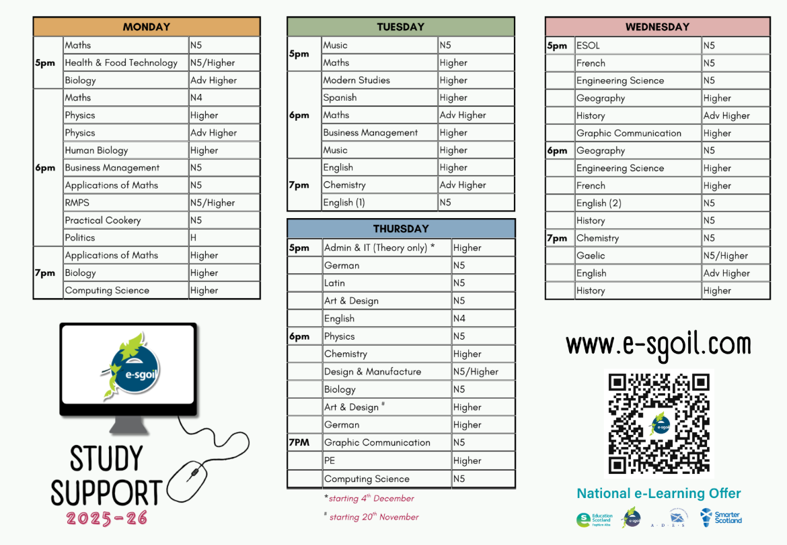
Supporting your child in the Senior Phase

Managing time
The number of priorities on your child's time often makes it difficult for them to decide where to start and what to do next. Encourage them to start revising in good time to avoid cramming and panic.
- Plan work so that deadlines are met comfortably.
- Make a realistic and achievable revision timetable for exams and include breaks and rewards.
- Stick to the revision timetable.



Morgan Connects

Getting organised
- Try to decide on a fixed area at home where they can study with the least number of distractions. Make sure that they have their laptop, pens, pencils, paper, notebooks, snacks and water.
- Try to prevent any unnecessary distractions. If it is difficult for your child to study at home, ask school if it can help.
- Encourage your child to use One-Note to organise their learning for each subject they are studying. Having notes organised into topic areas for each subject may be helpful.

Tips to encourage studying
- It is important to take breaks. Hour long revision sessions with short regular breaks of 10 minutes can be effective.
- Try to complete each task and then build in a break rather than stick to definite time slots. It is the quality of studying which is important.
- Work out how your child learns best.
  - reading through revision notes,
  - reading aloud,
  - recording and playing back information
  - explaining topics to others
  - writing out key facts
  - being tested by others
  - practice questions and papers under timed conditions.

Keeping well
- Get plenty of sleep. This is particularly important the night before an assessment. It can improve performance.
- Eat well.
- Avoid any unnecessary anxiety or panic by arriving on time and prepared for assessments.
- Encourage exercise.
- Keep an eye on your screen time.







Additional support needs/disabilities
Parents and carers should contact their child’s school to discuss the different types of support available. Please contact your child’s Guidance Teacher.

Other helpful links
SQA support for parents/carers - Information to help you support your child if they are studying National Qualifications.

SQA support for learners – Information to help children stay informed and prepare for their assessments in 2025/26.
Support for pupils who are worried about exams on the Reach website.

